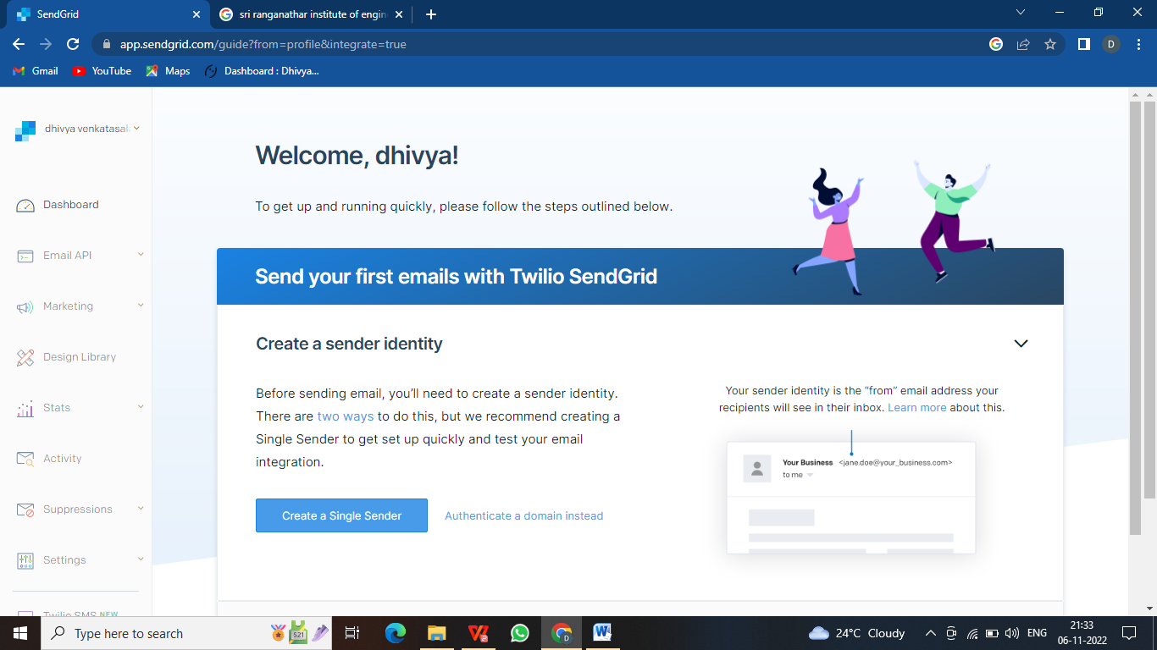 **SENDGRID ACCOUNT CREATION**

**TEAM LEADER-DHIVYA**

**TEAM MEMBER-HEROSHA**

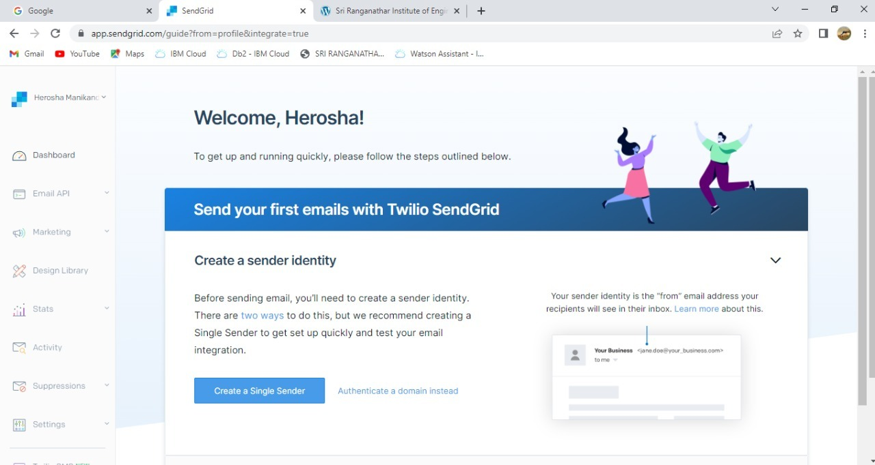

**TEAM MEMBER –SAHAYA DELPHIN**

